API FOR MOBILE APPLICATION DEVLOPEMENT

Using the Odoo API for mobile app development involves leveraging Odoo's web services, which are based on XML-RPC and JSON-RPC protocols.
Odoo provides two primary APIs:
- XML-RPC: A protocol that allows applications to communicate over the internet.
- JSON-RPC: A protocol similar to XML-RPC but uses JSON for data transfer, making it more suitable for web and mobile applications.
JSON RPC would be better for us because of JSON's response.
Examples of JSON RPC API
1. Authentication
Endpoint: /web/session/authenticate
Purpose: Authenticate a user and establish a session.
Body: {
"jsonrpc": "2.0",
"params": {
"db": "final",
"login": "final@gmail.com",
"password": "final"
}
}
Response:
{
"jsonrpc": "2.0",
"id": null,
"result": {
"uid": 2,
"is_system": true,
"is_admin": true,
"is_internal_user": true,
"user_context": {
"lang": "en_US",
"tz": "Asia/Kolkata",
"uid": 2
},
"db": "odoo",
"user_settings": {
"id": 1,
"user_id": {
"id": 2
},
"is_discuss_sidebar_category_channel_open": true,
"is_discuss_sidebar_category_chat_open": true,
"push_to_talk_key": false,
"use_push_to_talk": false,
"voice_active_duration": 200,
"volume_settings_ids": [
[
"ADD",
[]
]
]
},
"server_version": "17.0",
"server_version_info": [
17,
0,
0,
"final",
0,
""
],
"support_url": "https://www.odoo.com/buy",
"name": "Administrator",
"username": "ami.desai",
"partner_display_name": "Administrator",
"partner_id": 3,
"web.base.url": "https://saumithouse.effezient.com",
"active_ids_limit": 20000,
"profile_session": null,
"profile_collectors": null,
"profile_params": null,
"max_file_upload_size": 134217728,
"home_action_id": 724,
"cache_hashes": {
"translations": "f5296a2515224ba713ff03b910fcc2a9a1214c26",
"load_menus": "9dd38f1bd32e5b01469938a432efc3539355b15a34d0b4787b2c88c835850f70"
},
"currencies": {
"20": {
"symbol": "₹",
"position": "before",
"digits": [
69,
2
]
},
"1": {
"symbol": "$",
"position": "before",
"digits": [
69,
2
]
}
},
"bundle_params": {
"lang": "en_US"
},
"user_companies": {
"current_company": 1,
"allowed_companies": {
"12": {
"id": 12,
"name": "Chitali",
"sequence": 10,
"child_ids": [],
"parent_id": 1
},
"11": {
"id": 11,
"name": "Ketan M Javeri",
"sequence": 10,
"child_ids": [],
"parent_id": 1
},
"13": {
"id": 13,
"name": "Reema K Javeri",
"sequence": 10,
"child_ids": [],
"parent_id": 1
},
"3": {
"id": 3,
"name": "Saumit Fincon Service LLP",
"sequence": 10,
"child_ids": [],
"parent_id": 1
},
"14": {
"id": 14,
"name": "Saumya Jhaveri",
"sequence": 10,
"child_ids": [],
"parent_id": 1
},
"4": {
"id": 4,
"name": "Saumit Insurance Brokers Private Ltd",
"sequence": 11,
"child_ids": [],
"parent_id": 1
},
"1": {
"id": 1,
"name": "Saumit House",
"sequence": 0,
"child_ids": [
12,
11,
13,
3,
14,
4
],
"parent_id": false
}
},
"disallowed_ancestor_companies": {}
},
"show_effect": true,
"display_switch_company_menu": true,
"user_id": [
2
],
"max_time_between_keys_in_ms": 100,
"web_tours": [],
"tour_disable": false,
"notification_type": "inbox",
"odoobot_initialized": true,
"is_quick_edit_mode_enabled": false
}
}
This is the first API for establishing the connection between odoo and our application

2. Fetch User Data, Menus, and Access Rights
Endpoint: /web/dataset/call_kw (Same endpoint and different different Params)
Method: POST
2.1 Fetch User Data
Body:
{
"jsonrpc": "2.0",
"method": "call",
"params": {
"model": "res.users", #Odoo Modules
"method": "read", #display method
"args": [[2]], #user_id
"kwargs": {"fields": ["id", "name", "email", "groups_id"]} #adjust according to you
},
"id": 1
}

Response:
{
"jsonrpc": "2.0",
"id": 1,
"result": [
{
"id": 2,
"name": "Administrator",
"email": "ami.desai@effezzient.com",
"groups_id": [
2, 8, 36, 62, 65, 76, 68,43,59,51, 16,20,28,30,3,9,69,75,1,66,12,24,78,5,6,
77,67,50,61,64,49,40,13,4,17,7,60,48,45,47,42,15,14,63,35
]
}
]
}

2.2 Fetch Menus
Body:
{
"jsonrpc": "2.0",
"method": "call",
"params": {
"model": "ir.ui.menu",
"method": "search_read",
"args": [[], ["name", "id", "parent_id"]],
"kwargs": {}
},
"id": 1
}
Response:
{
"jsonrpc": "2.0",
"id": 1,
"result": [
{
"id": 60,
"name": "Users",
"parent_id": [
3,
"Settings/Users & Companies"
]
},
{
"id": 66,
"name": "General Settings",
"parent_id": [
1,
"Settings"
]
},
{
"id": 152,
"name": "Settings",
"parent_id": [
151,
"CRM/Configuration"
]
},
{
"id": 197,
"name": "Settings",
"parent_id": [
196,
"Invoicing/Configuration"
]
},
{
"id": 280,
"name": "Settings",
"parent_id": [
279,
"Project/Configuration"
]
},
{
"id": 312,
"name": "Settings",
"parent_id": [
299,
"Employees/Configuration"
]
}]
#All the Menus

}

2.3 Fetch Access Rights
Body:
{
"jsonrpc": "2.0",
"method": "call",
"params": {
"model": "res.groups",
"method": "search_read",
"args": [[["users", "=", 2]], ["name"]], #adjust according to you
"kwargs": {}
},
"id": 1
}
Response:
{
"jsonrpc": "2.0",
"id": 1,
"result": [
{
"id": 2,
"name": "Access Rights"
},
{
"id": 8,
"name": "Access to export feature"
},
{
"id": 36,
"name": "Admin"
},
{
"id": 62,
"name": "Administrator"
},
{
"id": 65,
"name": "Administrator"
},
{
"id": 76,
"name": "Administrator"
},
{
"id": 68,
"name": "Administrator"
},
{
"id": 43,
"name": "Administrator"
},
{
"id": 59,
"name": "Administrator"
},
{
"id": 51,
"name": "Administrator"
},
{
"id": 16,
"name": "Administrator"
},
{
"id": 20,
"name": "Analytic Accounting"
},
{
"id": 28,
"name": "Billing"
},
{
"id": 30,
"name": "Billing Administrator"
},
{
"id": 3,
"name": "Bypass HTML Field Sanitize"
},
{
"id": 9,
"name": "Contact Creation"
},
{
"id": 69,
"name": "Display CV on application form"
},
{
"id": 75,
"name": "Employee Manager"
},
{
"id": 1,
"name": "Internal User"
},
{
"id": 66,
"name": "Interviewer"
},
{
"id": 12,
"name": "Mail Template Editor"
},
{
"id": 24,
"name": "Manage Product Variants"
},
{
"id": 78,
"name": "Manager"
},
{
"id": 5,
"name": "Multi Companies"
},
{
"id": 6,
"name": "Multi Currencies"
},
{
"id": 77,
"name": "Officer"
},
{
"id": 67,
"name": "Officer: Manage all applicants"
},
{
"id": 50,
"name": "Officer: Manage all employees"
},
{
"id": 61,
"name": "Officer: Manage all requests"
},
{
"id": 64,
"name": "Officer: Manage attendances"
},
{
"id": 49,
"name": "Onboarding todo already generated for those users"
},
{
"id": 40,
"name": "Quotation Templates"
},
{
"id": 13,
"name": "Receive notifications in Odoo"
},
{
"id": 4,
"name": "Settings"
},
{
"id": 17,
"name": "Show Lead Menu"
},
{
"id": 7,
"name": "Technical Features"
},
{
"id": 60,
"name": "Time Off Responsible"
},
{
"id": 48,
"name": "Use Milestones"
},
{
"id": 45,
"name": "Use Stages on Project"
},
{
"id": 47,
"name": "Use Task Dependencies"
},
{
"id": 42,
"name": "User"
},
{
"id": 15,
"name": "User: All Documents"
},
{
"id": 14,
"name": "User: Own Documents Only"
},
{
"id": 63,
"name": "User: Read his own attendance"
},
{
"id": 35,
"name": "Validate bank account"
}
]
}

3. CRUD OPERATIONS
3.1 For Creating Records
End Point: /web/dataset/call_kw
{
"jsonrpc": "2.0",
"method": "call",
"params": {{
"jsonrpc": "2.0",
"id": 1,
"result": 137
} "model": "res.partner", // The model where you want to create a record
"method": "create",
"args": [{
"name": "John Doe", // The fields and values for the new record
"email": "john.doe@example.com" //you can increase according to Your Requirement
}],
"kwargs": {}
},
"id": 1
}
Response:
{
"jsonrpc": "2.0",
"id": 1,
"result": 137
}
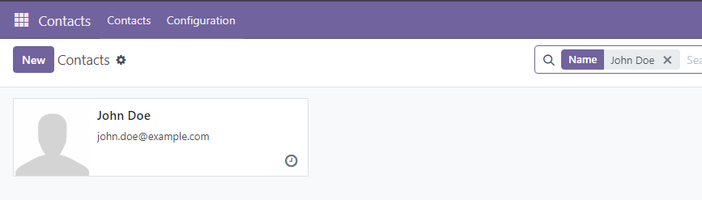

3.2. Read a Record (Read)
Body:
{
"jsonrpc": "2.0",
"method": "call",
"params": {
"model": "res.partner", // The model to read from
"method": "read",
"args": [[45], ["name", "email"]], // IDs of the records and the fields you want to retrieve
"kwargs": {}
},
"id": 1
}
Response:
{
"jsonrpc": "2.0",
"id": 1,
"result": [{
"id": 45,
"name": "John Doe",
"email": "john.doe@example.com"
}]
}

3.3 Update a Record (Update)
Body:
{
"jsonrpc": "2.0",
"method": "call",
"params": {
"model": "res.partner", // The model to update
"method": "write",
"args": [[45], { // ID of the record(s) to update and the fields to modify
"email": "john.newemail@example.com"
}],
"kwargs": {}
},
"id": 1
}
Response:
{"jsonrpc": "2.0", "id": 1,"result": true}

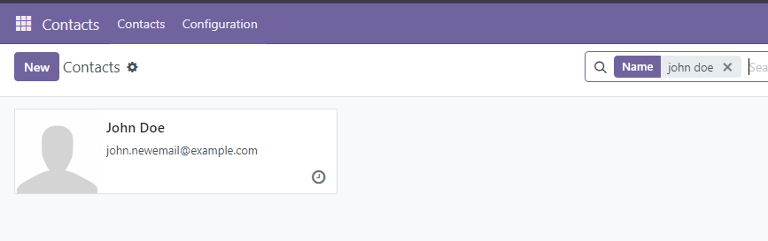

3.4 Delete a Record (Delete)
Body:
{
"jsonrpc": "2.0",
"method": "call",
"params": {
"model": "res.partner", // The model to delete from
"method": "unlink",
"args": [[137]], // ID of the record(s) to delete
"kwargs": {}
},
"id": 1
}
Response:
{
"jsonrpc": "2.0",
"method": "call",
"params": {
"model": "res.partner", // The model to delete from
"method": "unlink",
"args": [[45]], // ID of the record(s) to delete
"kwargs": {}
},
"id": 1
}
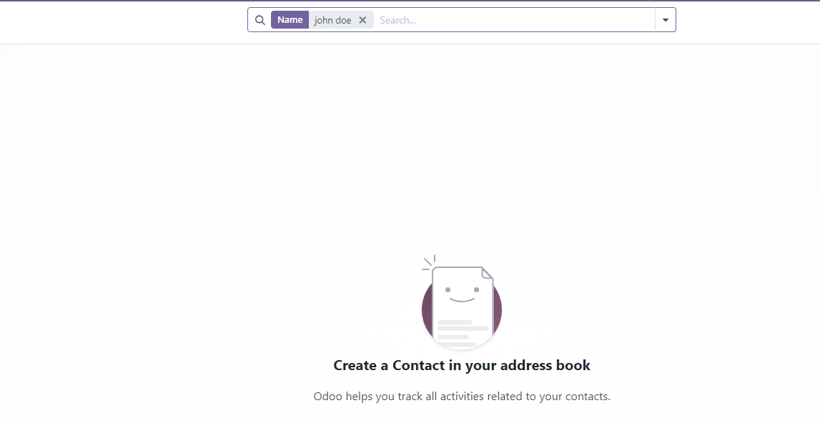

SESSION VALIDITY
The session in Odoo typically has a default expiration time of 60 minutes (1 hour) of inactivity. If there is no activity (i.e., no API calls or actions) for this period, the session will expire, and the user will need to log in again.
As long as there is ongoing activity (e.g., regular API calls), the session will remain valid and not expire until the inactivity threshold is reached.
Odoo does not provide a built-in mechanism for automatically renewing a session in the background without making an API call. However, you can design your app to detect when the session is about to expire and make an appropriate call to renew it.

- Manual Logout:
The session will also be terminated if the user explicitly logs out through the API or web interface.
- Session Renewal:
If you want to keep the session alive, you can implement a mechanism in your app to periodically request the Odoo server to refresh the session before it expires.
how do you do it?
1. Choose a Keep-Alive Interval:
Determine a suitable interval for sending keep-alive requests. This interval should be less than the session timeout period (e.g., if the timeout is 60 minutes, you might want to send a request every 50 minutes to be safe).
2. Select a Lightweight API Endpoint:
Choose a lightweight API endpoint that doesn't require much processing on the server. The res.users model's check_access_rights method is a good option, as it is simple and doesn't affect any data.
{
"jsonrpc": "2.0",
"method": "call",
"params": {
"model": "res.users",
"method": "check_access_rights",
"args": ["read", false]
},
"id": 1
}

Response:
{
"jsonrpc": "2.0",
"id": 1,
"result": true
}

- Implement Keep-Alive in Android:
For App Developer ;)

Thank You

